

FOREST FIRE

**Supervised By:**

**Done By**:

KALLAMADI RUTVA

NELLUTLA.MAHESHWARI

K.RAKSHITH REDDY

SYED RAHEEL

**CERTIFICATE**

This is to certify that Kallamadi Rutva , N.Maheshwari , k.Rakshith Reddy, Syed Raheel enrolled in the B.E degree programme (Computer Science Engineering) of the Stanley college of engineering and technology for women,Hyderabad and has successfully completed the four week internship cum hands-on training program conducted by Smart bridge at Stanley College Of Engineering and Technology for Women in ‘Introduction to Machine Learning using Python and IBM Watson’ during the time period from 3rd June, 2019 to 23rd June, 2019 under the guidance of Mrs. Pradeepthi, Senior Data Consultant. During this period of internship with us they found punctual, hardworking and inquisitive.

_____________________

Mentor

FOREST FIRE

1.1 INTRODUCTION

The most common hazard in forests is forests fire. They pose a threat not only to the forest wealth but also to the entire regime to fauna and flora seriously disturbing the bio-diversity and the ecology and environment of a region. During summer, when there is no rain for months, the forests become littered with dry senescent leaves and twinges, which could burst into flames ignited by the slightest spark. ? Forest fire causes imbalances in nature and endangers biodiversity by reducing faunal and floral wealth. Traditional methods of fire prevention are not proving effective and it is now essential to raise public awareness on the matter, particularly among those people who live close to or in forested areas

CAUSES OF FOREST FIRE: Causes of forest fires can be divided into two broad categories: environmental (which are beyond control) and human related (which are controllable). Many forest fires start from natural causes such as lightning which set trees on fire. However, rain extinguishes such fires without causing much damage. High atmospheric temperatures and dryness (low humidity) offer favourable circumstances for a fire to start.

Human related causes result from human activity as well as methods of forest management. These can be intentional or unintentional, for example: graziers and gatherers of various forest products starting small fires to obtain good grazing grass as well as to facilitate gathering of minor forest produce. The centuries old practice of shifting cultivation (especially in the North-Eastern region of India and in parts of the States of Orissa and Andhra Pradesh). The use of fires by villagers to ward off wild animals fires lit intentionally by people living around forests for recreation

EFFECT OF FOREST FIRE: loss of valuable timber resources degradation of catchment areas loss of biodiversity and extinction of plants and animals loss of wildlife habitat and depletion of wildlife loss of natural regeneration and reduction in forest cover global warming loss of carbon sink resource and increase in percentage of CO2 in atmosphere change in the microclimate of the area with unhealthy living conditions

Soil erosion affecting productivity of soils and production ozone layer depletion health problems leading to diseases loss of livelihood for tribal people and the rural poor, as approximately 300 million people are directly dependent upon collection of non-timber forest products from forest areas for their livelihood.

THE NEEDS OF THE FIRE MANAGEMENT: The incidence of forest fires in the country is on the increase and more is burned each year .The major cause of this failure is the piecemeal approach to the problem. Both the national focus and the technical resources required for sustaining a systematic forest fire management elements like strategies fire centres.

1.2 Objectives of research

To determine the impact of forest fire on forest cover types classification and change detection of study area using multi-temporal.

* To develop forest cover classification scheme from satellite image interpretation and forest distribution scope(altitude)
* To evaluate forest cover change from different temporal scales.
* To determine how the forest fire influences the forest cover types
* To facilitate forest inventory by integrating satellite data analysis and ground survey

1.3Problem statement

The inability to accurately predict fire behaviour conditions and understand public information needs can lead to inefficient use of resources to prevent, suppress and control wild fires as well as prevent the use of prescribed fire as an efficient land management tool. Large forest fire impacts are not fully understood and information is needed to address restoration following these types of fire.

1.4 industry profile

The economic backbone of many BC communities, forestry is a vital part of BC’s economy. The sector continues to recover from 2009, one of the worst years for the industry in recent history, with expanded export markets in Asia, pulp product specialization, and continued expansion into green energy. The BC forestry industry is a world leader in sustainable forest management with more land certified to internationally recognized sustainability standards than any other jurisdiction in the world. Accounting for nearly a quarter of all direct manufacturing employment in BC, the forestry industry supports 145,800jobs, with annual revenue of $15.7 billion. The industry consists of more than 7,000 businesses in BC – most of which are small businesses employing less than 20 employees – and is a major customer for BC’s transportation industries. An estimated 14 million metric tonnes of forest cargoshipped through bc ports annually to more than 25 countries. In this issue, CPABC Industry Update examines the economic impact of the forestry industry on BC’s economy, sustainability certification and forest management practices, data revolutions in forest monitoring, and Aboriginal title to land, and also includes a Q&A with members working in the forestry industry. Next issue, you’ll notice some changes to Industry Update – we’ll be including more articles addressing issues facing members in industry, in addition to our focus on a specific industry. These changes are being made based on feedback from the member satisfaction survey conducted this past spring. We hope you enjoy this edition of Industry Update, and look forward to your feedback on this and future issues.

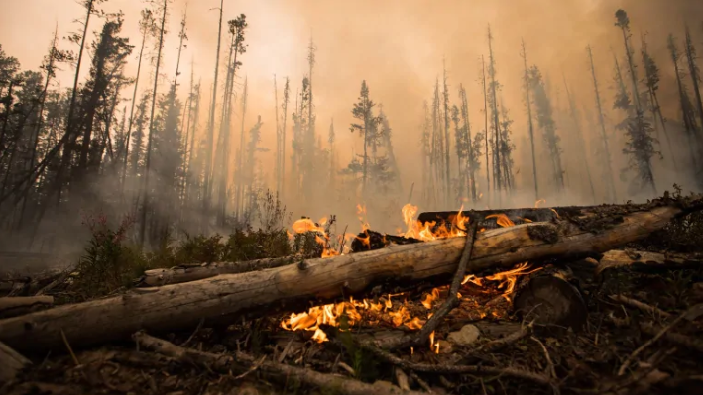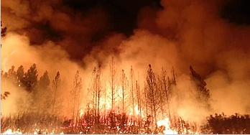

2. Review of Literature

Current resources need to be redirected to support research that improves the understanding of fire causes and effects and identifies existing management practices that predispose ecosystems to harmful fires. Forest departments need to invest more in the promotion of management systems that mimic natural fire regimes or take advantage of well-established fire use or natural fire; develop tactics to prevent recurring harmful fires; establish reliable fire monitoring programs and strengthen the involvement of key stakeholders, especially local communities, in fire management.

The World Conservation Union (IUCN), The Nature Conservancy (TNC) and The Worldwide Fund for Nature (WWF) have come together to work proactively with multi-lateral agencies, governments, private sector and local communities to develop integrated fire management approaches that address underlying causes and develop long-term sustainable solutions. The core elements of such an approach must include:

* Supporting research to improve the understanding of forest fires and their ecology, ecological and social costs and benefits, causes and management options.
* Building awareness amongst policy-makers, the public and the media of the underlying causes of catastrophic forest fires.
* Mandating and equipping managers to implement integrated fire management programs.
* Involving local communities and land managers in management planning and implementation, assisting them to participate effectively.
* Developing and enforcing compatible and mutually reinforcing land-use laws that provide a legal basis for the ecologically appropriate use of fire.
* Discouraging land management practices that predispose forests to harmful fires.
* Promoting management strategies to mimic natural fire regimes, including techniques such as prescribed burns and managed wildfires.
* Avoiding manipulating natural or well-established fire regimes.

3 Data collection

* We did a lot of research for data collection. We referred some books, PDFs, and some other sources on the internet. We need a real time data for preparing the model. Forest fire data has been collected from Aranya bhavan ,TelanganaState ,Forest department , Head office.
* The dataset is available in the form of csv with 518entries of data of 11 attributes (x , y , month , day , FFMC , DC , ISI , temp , wind , rain ,area)
* In order to read and use this data, as well as implement the SVM, the language python was used and was done in the IBM CLOUD environment.

4 Methodology

* Support Vector Machine (SVM) was first heard in 1992, introduced by Boser, Guyon, and Vapnik in COLT-92. Support vector machines (SVMs) are a set of related supervised learning methods used for classification and regression. They belong to a family of generalized linear classifiers.
* Support Vector Machine (SVM) is a classification and regression prediction tool that uses machine learning theory to maximize predictive accuracy while automatically avoiding over-fit to the data.
* Support Vector Machines (SVM) features such as better empirical performance. The formulation uses the Structural Risk Minimization (SRM) principle, which has been shown to be superior , to traditional Empirical Risk
* Minimization (ERM) principle, used by conventional neural networks. SRM minimizes an upper bound on the expected risk, where as ERM minimizes the error on the training data. It is this difference which equips SVM with a greater ability to generalize, which is the goal in statistical learning. SVMs

Data analysis:

* From the original data examples with missing values were removed .
* Total number of observations in dataset: **518**
* Total number of attributes in dataset : **13**
* Metadata and attribute information:

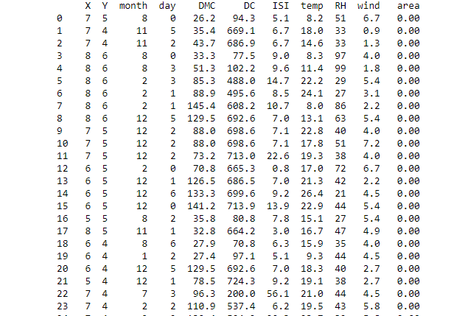

4.1 Exploratory Data Analysis

In this notebook we perform an exploratory data analysis over the forest fire Dataset. In this analysis we seek to understand the distribution of the dataset attributes, as well as the relationship between them.

The analysis is divided in sections:

* We present the forest fire Dataset and their attributes:
* We perform the analysis of each attribute individually.
* We seek for correlations between the attributes and how the segmentation affects the results.

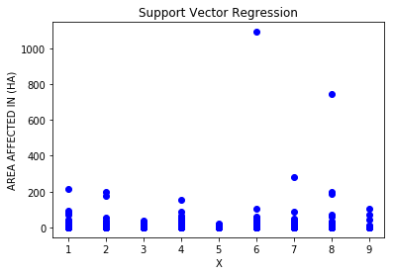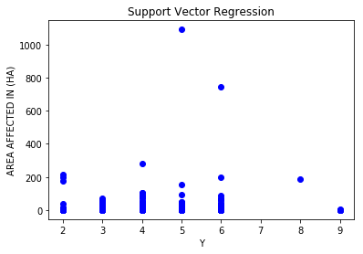

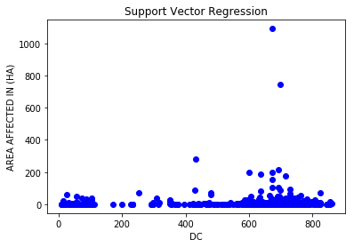

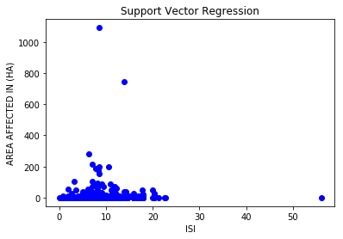

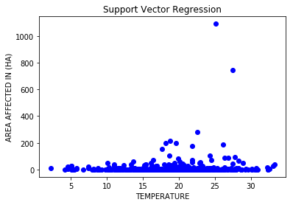

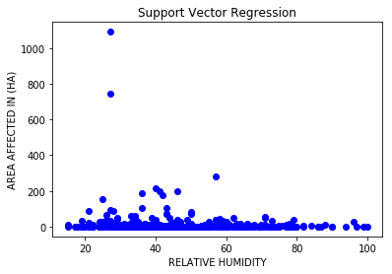

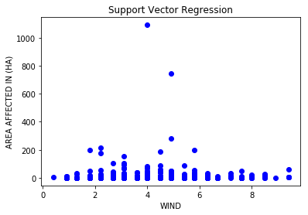

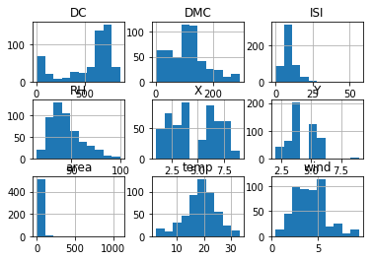

GRAPHS

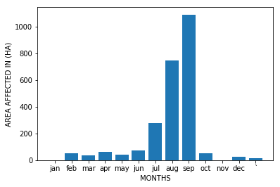

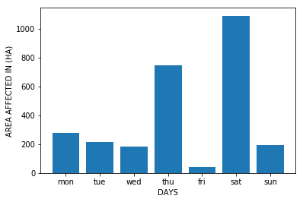

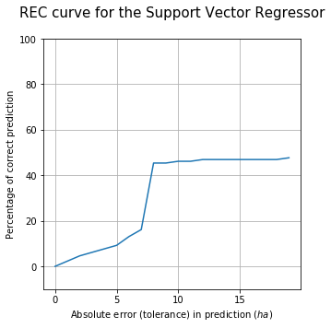

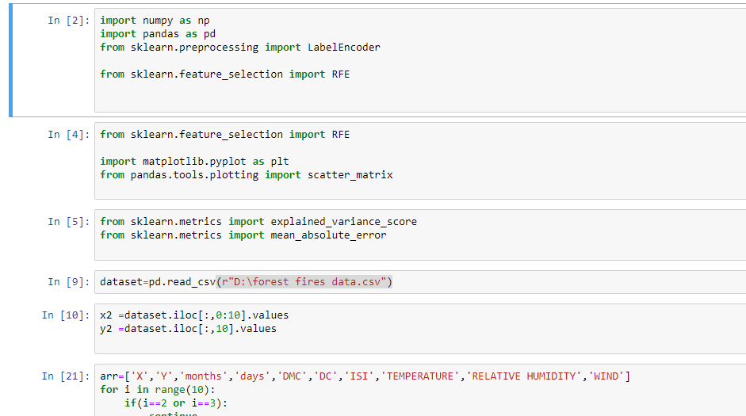

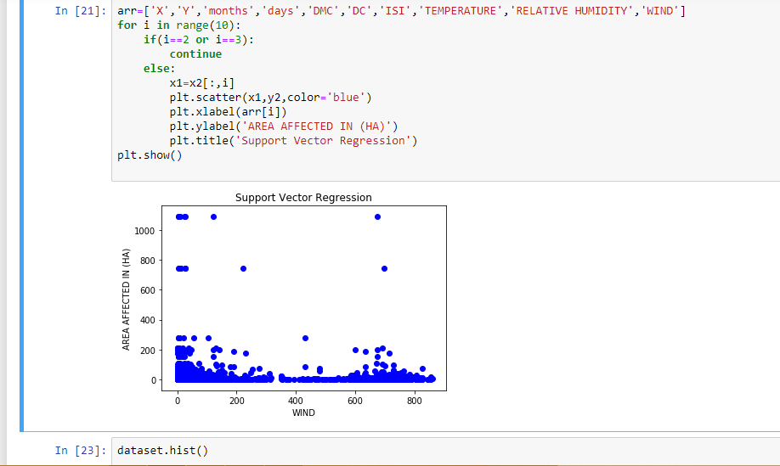

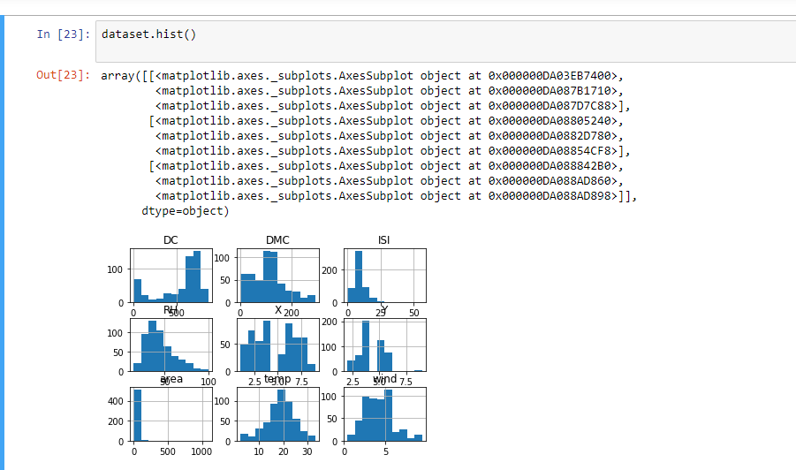

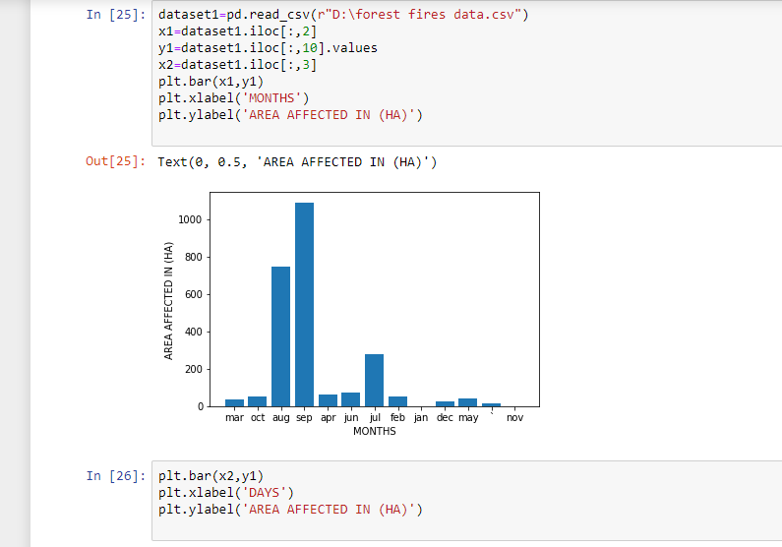

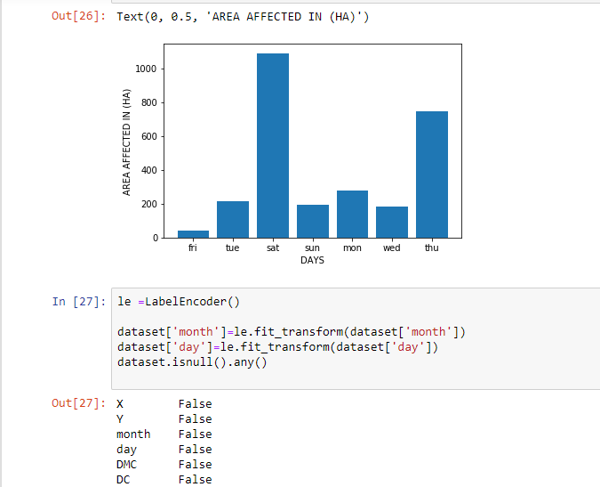

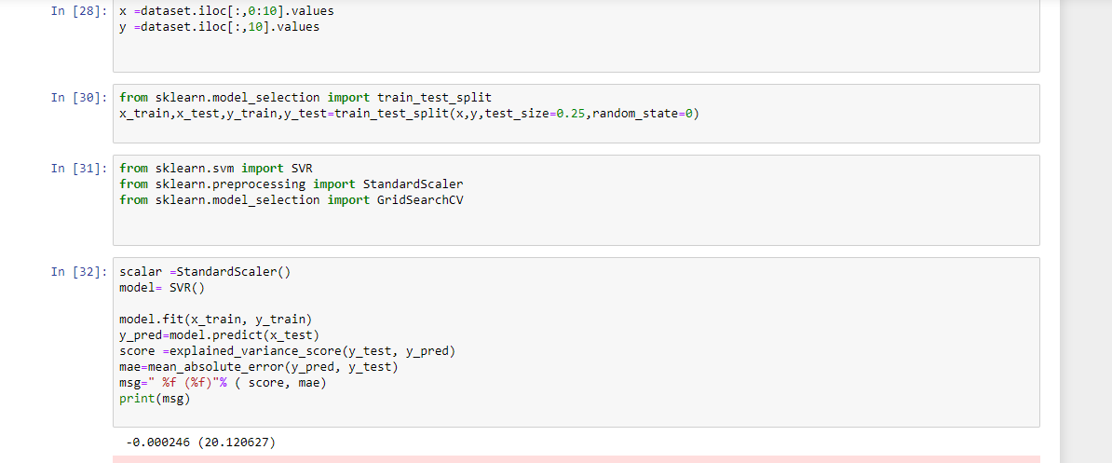

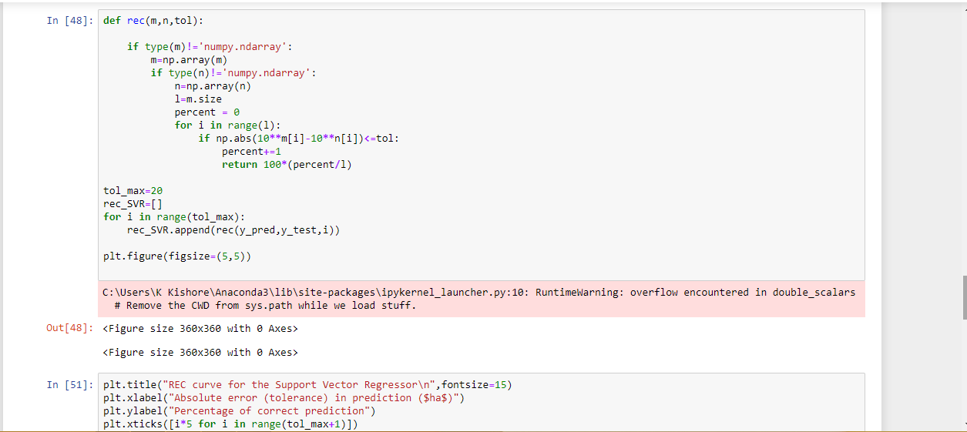

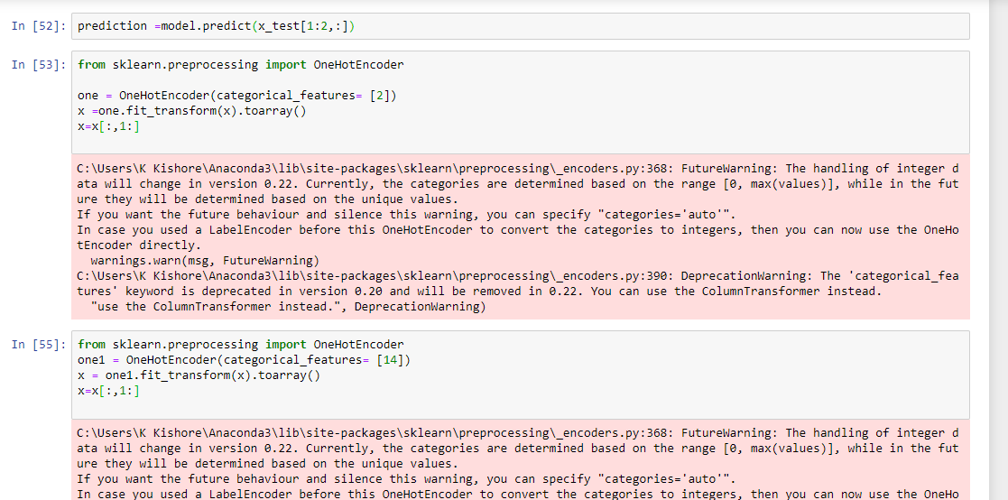

5 Findings and suggestions

* Be informed
* Take precautions
* Protect yourself from smoke

Be informed: The danger of fire in your region in your region or in the sector where you intend to go, and the preventive measures in effect. These measures may consist in:

* A ban on open fires in the forest or nearby
* The municipal by-laws governing outdoor fires
* The instructions in effect in controlled zones (ZECs), parks and reserves
* The restrictions on access to the forest, as well as on travel, work and burning in the forest

Take precautions: Here is what you can do for your protection

* Always have and within reach (at the cottage, in your backpack when hiking in the forest).

* Store building materials, firewood and propane tanks more than 10 m away from any building on your land; clear away all vegetation within a radius of 3 m of the propane storage tank in order to reduce the risk of a fire spreading.
* Intervene promptly if a fire starts.
* Choose a cleared location, out of the wind, for a fire outside; have a shovel, a bucket of water or a rake nearby, constantly monitor your fire and, to extinguish it, spray it with abundant water and cover it with ash, sand or earth.
* Burn anything (waste, dead leaves) at the end of the day, when there is no wind, far from vegetation and in compliance with municipal by-laws.
* If you smoke outside, put out your cigarette butt on a rock or bury it in the ground.

Protect yourself from smoke:

The smoke caused by a forest fire moves according to the speed of the wind.

The following people are more likely to be bothered by the smoke:

* Young children
* The elderly
* People with respiratory problems such as asthma and bronchitis
* People with heart problems
* Listen carefully to public notices and warnings about the presence of smoke or the air quality
* Avoid outdoor activities when the air quality index is poor.
* Close the windows and doors of your home, along with the air exchange system, when there is smoke outside.
* Breathe into a damp cloth when in the presence of thick smoke, and be sure to keep the cloth in front of your mouth and nose in order to avoid inhaling smoke.​

**6 Conclusion**

* Forest fire is multi –sector issues
* Forest fire is a national problem,however,limited data inhibit its management,and most of the information is based on opinion.
* for fire concern
* A national campaign on forest fire management is needed

**Control strategies:**

* Public education
* Uses of laws,bylaws and regulations
* Participatory forest management i.e CBFiM
* Use of successful tradition al forest management systems
* Establishment of NFMC under TFS
* Anti-fire posters (“Usichome moto”)

7 BIBLOGRAPHY AND REFERENCES

The sites we referred to are shown as follows:-

<https://www.sciencedirect.com/topics/earth-and-planetary-sciences/forest-fire>

<http://vikaspedia.in/energy/environment/know-your-environment/forest-fires>

<https://github.com/topics/forest-fire>

<https://www.urgencequebec.gouv.qc.ca/En/situation-urgence/Pages/Incendie-de-foret.aspx>

<http://www.indiaenvironmentportal.org.in/files/file/Forest-Fire-Prevention-Management.pdf>